WORKSHOP W9
Applying current philosophical insights on causality using Qualitative Comparative Analysis as an additional synthesis in systematic reviews to address complex interventions
Submitted abstract:
Objectives
- Introduce current philosophical perspectives on causality to facilitate understanding of complex causal relationships in data.
- Introduce concepts of Qualitative Comparative Analysis (QCA), a methodology assuming complex causality.
- Demonstrate QCA synthesis in systematic reviews taking account of potential benefits, challenges and limitations.
Description: We outline causal philosophical accounts and a synthesis method from sociology, QCA. QCA allows synthesis of both quantitative and qualitative data. Its use may expand the systematic review toolkit for complex interventions to explore variance across studies. We show how these causal accounts operate within the QCA set theoretic approach: equifinality, asymmetry, and configurations of causal factors (10mins presentation). Participants ‘play’ with these concepts to increase understanding (5 mins). Using examples from systematic reviews facilitators outline the method familiarising participants with the ‘truth table’ – a matrix of cases, causal factors, and outcome with set membership scores (15 mins presentation). Participants will compare case examples of systematic reviews with and without a QCA synthesis to explore difference in approaches (50 mins, group work and feedback). We end with discussion using participants’ own experience of challenging, multi-component, complex interventions in complex contexts and whether QCA has utility in the systematic review environment (10 mins discussion).
WE WILL FINE TUNE THESE TIMINGS.
PARTICIPANT INFORMATION SHEET
Introduction
This workshop briefly introduces concepts of complex causality and a set of methods pioneered by Charles Ragin to address complex causal relations in social systems. The method Qualitative Comparative Analysis (QCA) is described as a case-based approach that sits between case study and variable oriented approaches. It aims to achieve a deep holistic understanding of ‘cases’, i.e. interventions, their features and the context in which they occur. Ragin would describe QCA as a research strategy that combines attributes of variable and case orientated research, Fig 1. Cases are compared to observe patterns in the variables across cases. Heterogeneity is assumed amongst cases that result in the same outcome allowing exploration of variation between cases. QCA is quite different to the net effects approach of meta-analysis. That is, it does not provide statistical inference but infers the best explanation, meaning it examines processes and mechanisms retrospectively across cases with a pre-defined outcome of interest. This method originated from historical and political science to model the complex reality of the social world and social relationships. It is important not to be misled by the ‘Qualitative’ in QCA. Data can come from a range of sources, trials, surveys, epidemiological studies, qualitative research, etc.
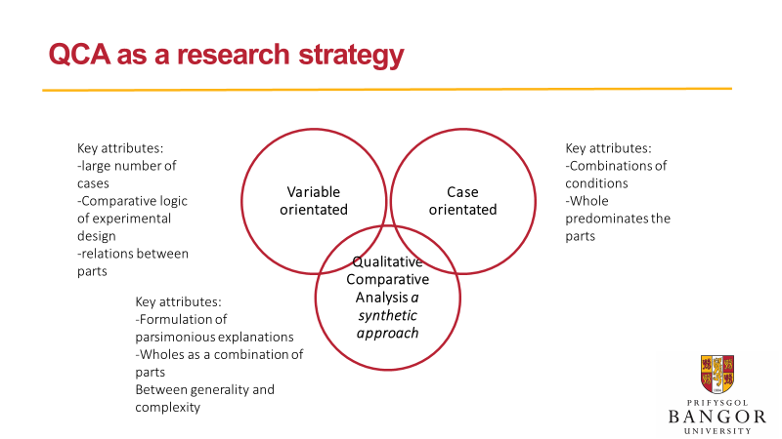
Slide provided by J. Chandler, PhD student, Bangor University.
Fig. 1
The following fig. 2 and 3 compare and distinguish QCA with both qualitative and quantitative methods.
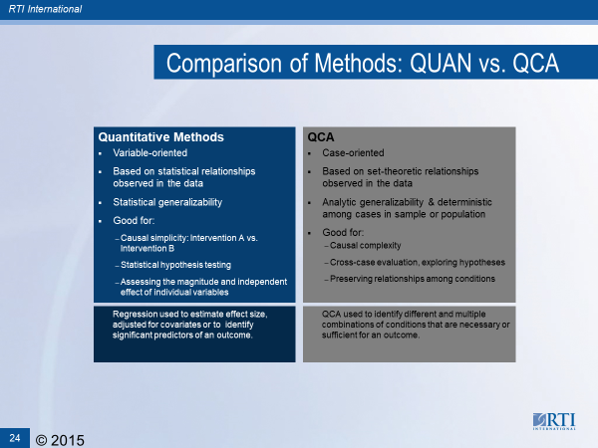
Slide provided by L. Kahwati, RTI
Fig. 2
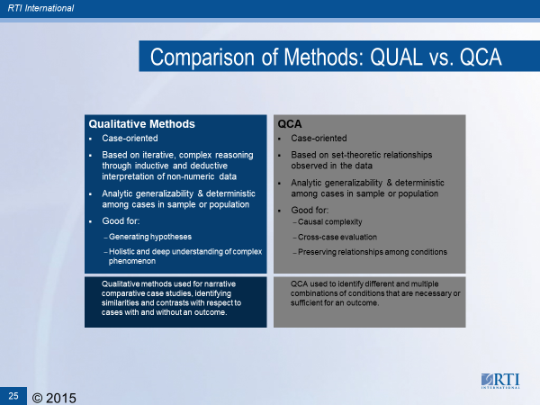
Slide provided by L. Kahwati, RTI
Glossary of key terms
Equifinality: Permits different configurations of sufficient conditions in a pathway to an outcome.
Asymmetry: When a condition is present or absent denotes two qualitatively different states, that is, absence is not the opposite of presence.
Multiple Conjunctural Causation: conceives causality as a combination of conditions that generate an outcome, and can entail several different combinations to the same outcome. Also, due to asymmetry a single condition may either be present or absent in the different combinations.
Cases: A pre-defined discrete entity of which there are enough examples for comparison: a country, a patient, a process or pathway, a trial, etc.
Configurations: A combination of conditions that are either observed across selected cases or hypothetical cases (not observed in the sample of cases but are logically possible).
Conditions:
Fig. 3
Key concepts
Key concepts of causal complexity within this method are arrangements of pre-specified conditions (causal) and whether they are either necessary or sufficient for outcome occurrence. The key features of these causal relations using set theory are asymmetry, equifinality and multiple conjunctural causation.
QCA is based on mathematical principles of set theory (Boolean algebra) and the notion of the social world as set theoretic in nature. Sets are a collection of objects that relate to each other under a specified set of rules, and so clarity of set membership is important. We are very familiar with what constitutes a set as illustrated in a Venn diagram where two or more sets show an overlap. This shows that a ‘thing’ can be a member of two sets. For example, an apple belongs to both the set ‘fruit’ and ‘plant’. In contrast to statistical techniques that serve to identify statistical correlations or associations in the data that are symmetrical, QCA identifies set relationships in the data, and set theory assumes that membership in a set and membership negation (not in the set) are different qualitative states in the social world and so do not act as a mirror. Thus, set relations are asymmetrical. QCA techniques will define set membership either as present (1) or absent (0) (Crisp set QCA), or partially in the set (1, 0.75, 0.5, 0.33, 0). This membership scoring is calibrated against an agreed or dependable standard with a set of rules for set membership.
Using the notion of sets, QCA analyse data obtained across pre-defined set of cases to address configural research questions, which are questions that take the general form “what combinations of features are found among cases with a specified outcome?” If used in a systematic review, for example, the ‘case’ could be the study or trial. The set of cases would, ideally for purposes of comparison, consist of those with the outcome present and those with the outcome not present. In a systematic review this might relate to effective and not effective results for the outcome of interest. The more complex part of QCA is “condition” specification. Conditions are the potential causal factors for the outcome to occur, and in a systematic review context, may be the features of a complex intervention or the study population or setting. Conditions may combine in different configurations across the cases in relation to achieving or not achieving the outcome. The concept of more than one causal pathway (i.e., configuration of conditions) is referred to as equifinality. QCA is also used as primary research strategy in non-systematic reviews.
Using sets to understand whether a case falls within a condition and outcome set or not underlies QCA. The configurational patterns of the set relations that are identified by QCA include relationships of sufficiency and necessity. QCA can identify complex arrangements of condition sets with respect to an outcome and this is referred to as multiple conjunctual causation.
Understanding sufficiency and necessity are important concepts to grasp. Fig 2. Illustrates these set relation arrangements in a Venn diagram and 2 x 2 table.
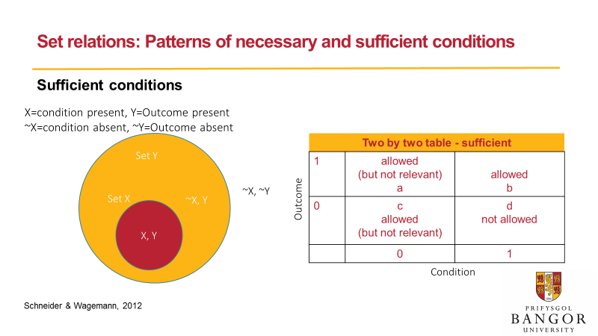
Definition of Sufficiency: “The outcome is always present when a sufficient condition (or combination of conditions) is present.” The outcome will always be found among cases with a sufficient condition, but the absence of a sufficient condition doesn’t guarantee the outcome will be absent as other sufficient conditions could be present that guarantee the outcome will be present (equifinality). X condition (red circle) only accounts for a subset of cases for the outcome Fig. 3
set Y (yellow circle) this is then translated in to a 2 x 2 table.
Slide provided by J. Chandler, PhD student, Bangor University.
Definition of Necessity: “The condition (or combination of conditions) is always present when the outcome is present.” Necessary conditions are always found among cases with the outcome, but their presence doesn’t guarantee the outcome will be present. However, the absence of a necessary condition will guarantee the outcome will be absent. (asymmetric causality). A subset of X condition (yellow circle) is necessary for the outcome set Y (red circle) this is then translated in to a 2 x 2 table.
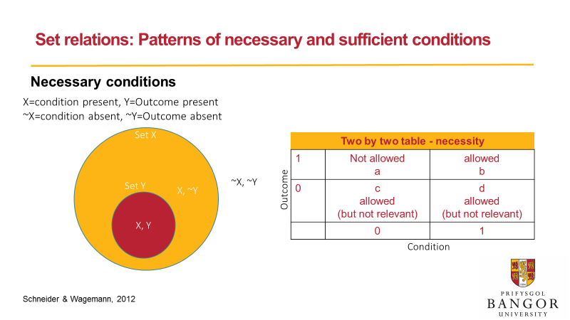
Slide provided by J. Chandler, PhD student, Bangor University.

Fig. 4
However, the complexity of the real world is such that set relations are not perfect but partial, so inconsistent findings are more likely. Likewise, any single condition is assumed to combine with other conditions to achieve the outcome. Therefore, based on heterogeneity in real world cases QCA offers several solutions, that is configurational combinations of conditions, that might lead to the same outcome. These ‘solutions’ represent different possible models that need interpretation within the boundaries of the initial assumptions, hypotheses and theory of the study context. The workshop is an opportunity to grasp the central ideas and how this technique can be used within systematic reviews. We provide a bibliography and advise a good read of selected papers before attendance at the workshop to make best use of time.
Session plan
This workshop will touch lightly on the QCA process and will address:
- Understanding key concepts
- formulating appropriate questions,
- selection and case definition and outcome of interest,
- identifying conditions,
- building a data table, constructing truth tables (the core analytic device used to conduct the analysis), and
- Interpretation of findings.

We will also discuss some of the method’s limitations and how to decide whether this approach would be useful to apply within a systematic review.

Bibliography
It would help to try and read the following papers. Some are easily available through open access others, through online institutional Libraries.
Papers
Strongly advised
Ragin C. (1999) Using Qualitative Comparative analysis to Study Causal Complexity. Health service Research; 34:5 Part II.
Schneider CQ, Wagemann C. (2010) standards of Good Practice in Qualitative Comparative Analysis and Fuzzy-sets. Comparative Sociology; 9:3 397.
Thomas, J., O'Mara-Eves, A., & Brunton, G. (2014). Using qualitative comparative analysis (QCA) in systematic reviews of complex interventions: a worked example. Syst Rev, 3, 67. doi:10.1186/2046-4053-3-67
Case examples of Using QCA within Systematic Reviews
Candy B, king M, Jones L, Oliver S. (2013) Using qualitative evidence on patients’ views to help understand variation in effectiveness of complex interventions: a qualitative comparative analysis. Trials; 14:179.
Forman-Hoffman, V. L., Middleton, J. C., McKeeman, J. L., Stambaugh, L. F., Christian, R. B., Gaynes, B. N., . . . Viswanathan, M. (2017). Quality improvement, implementation, and dissemination strategies to improve mental health care for children and adolescents: a systematic review. Implementation Science, 12(1), 93. doi:10.1186/s13012-017-0626-4
Harris, Katherine M., Dylan Kneale, Toby J. Lasserson, Vanessa M. McDonald, Jonathan Grigg, and James Thomas. "School‐based self management interventions for asthma in children and adolescents: a mixed methods systematic review (protocol)." The Cochrane Library (2015). DOI: 10.1002/14651858.CD011651
Kahwati, L., Jacobs, S., Kane, H., Lewis, M., Viswanathan, M., & Golin, C. E. (2016). Using qualitative comparative analysis in a systematic review of a complex intervention. Syst Rev, 5(1), 82. doi:10.1186/s13643-016-0256-y
Kahwati, L., Viswanathan, M., Golin, C. E., Kane, H., Lewis, M., & Jacobs, S. (2016). Identifying configurations of behavior change techniques in effective medication adherence interventions: a qualitative comparative analysis. Syst Rev, 5(1), 83. doi:10.1186/s13643-016-0255-z
Sutcliffe K, Richardson M, Rees R, Burchett H, Melendez-Torres GJ, Stansfield C, Thomas J (2016) What are the critical features of successful Tier 2 weight management programmes for adults? A systematic review to identify the programme characteristics, and combinations of characteristics, that are associated with successful weight loss. London: EPPI-Centre, Social Science Research Unit, UCL Institute of Education, University College London. https://eppi.ioe.ac.uk/CMS/Portals/0/PDF%20reviews%20and%20summaries/Weight%20management%202016%20Sutcliffe%20report.pdf
Sutcliffe K, Burchett H, Rees R, Stansfield C, Thomas J (2016), What are the critical features of successful Tier 2 lifestyle weight management programmes for children aged 0-11 years? A systematic review to identify the programme characteristics, and combinations of characteristics, that are associated with successful outcomes. London: EPPI Centre, Social Science Research Unit, Institute of Education, University College London. http://ac.els-cdn.com/S0091743517303110/1-s2.0-S0091743517303110-main.pdf?_tid=6e0701d8-946f-11e7-b077-00000aacb362&acdnat=1504859377_7639c4d134ea9965f10f830cc0e96997
For those seeking further reading the following textbooks are very useful:
Schneider, C. Q., & Wagemann, C. (2012). Set-theoretic methods for the social sciences. A guide to qualitative comparative analysis. Cambridge, United Kingdom: Cambridge University Press. – A substantial technical Handbook that provides a good glossary of terms.
Rihoux, B., & Ragin, C. (2009). Configurational comparative methods: qualitative comparative analysis (QCA) and related techniques. Thousand Oaks: Sage. Small manageable book with plenty of summary boxes of key points.
Ragin, C. (2008). Redesigning social inquiry: Fuzzy sets and beyond. Chicago: University of Chicago Press. For reference.
Ragin, C. (2000). Fuzzy-Set Social Science: U Chicago Press. For reference.

